

User Manual of My Fitness

Mobile app



June 27, 2024

My Fitness

User Manual

Bottom navigation bar 2

2

2

Home Screen 3

Home Page 4

Blog Page 5

Book Online Page 6

Plans Page 8

Join us Page 10

Shop Page 11

# Bottom navigation bar











# Badge 1 with solid fill

Click on the home icon to enter the **home page**



Click on the blog icon to enter the **blog page**



Click on the book online icon to enter the **Booking Online page**



Click on the Plans icon to enter the **Plans page**



Click on the Join us icon to enter the **Join us page**



Click on the Shop icon to enter the **Shop page**

# Home Screen

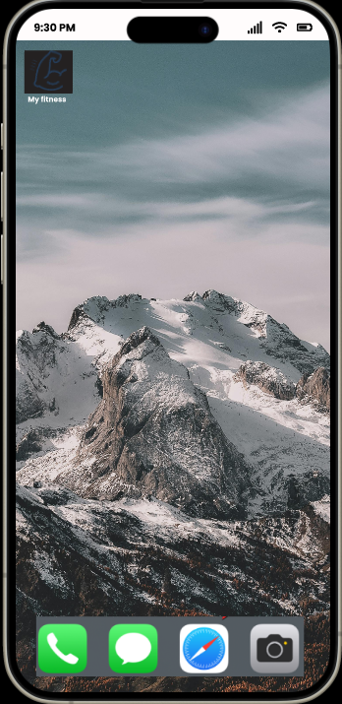



Click on My **fitness logo icon** to access the mobile app.

# Home Page

Tap the **exit icon** to return to the **home screen.**



Click the **Join Now button** to join the class.



Click on the **title** to view the latest article.

# Blog Page



Click on the **title** to view the latest article.

# Book Online Page



Click the **Select icon** to make the payment for joining the class. After that



Choose a payment method.



Fill the form and click the buy icon for the payment.



When you get to this page, it means that you have successfully made the payment

# Plans Page

Click the **Select icon** to make the payment for joining the membership.



Choose a payment method.



Fill the form and click the **buy icon** for the payment.



When you get to this page, it means that you have successfully made the payment

# Join us Page



After filling out your personal information, click **Join button** to join .



When you get to this page, it means that you have successfully join us.

# Shop Page

Click the **Buy button** to make the payment for the items.



Choose a payment method.



Fill the form and click the buy icon for the payment.



When you get to this page, it means that you have successfully made the payment